TOWN of PRICEVILLE
Book’n IT
For
Priceville

5K & 10K

Saturday
October 29, 2016

Priceville, AL

5k at 7:30am

10k at 8:30am

Priceville Public Library

This race benefits the Linda Duran Public Library.
CHIP Timing will be used. Please make an effort to pre-register to help us keep a tight schedule on race day. Thank You.
5K : pre-registration thru 10/1- $15, 10/1 thru 10/28- $20 (postmarked 10/26)
5K Race day-7:30am (10/29) $25 (06:00-07:00)
10K : pre-registration thru 10/1- $25, 10/1 thru 10/28- $30 ( postmarked by 10/26),
10K Race Day-08:30am (10/29) $35 (06:00-07:00)
RACE DAY REGISTRATION FOR BOTH RACES 06:00-07:00 ONLY
Please park in the back parking lot of Food Land or at Veteran’s Park. The start/finish area is a short walk north near the OLD Priceville Library on Faye Dr. in the large field

Book’n It for Priceville 5K/10K
DOWNLOAD FORM www.rivercityrunners.org
ENTRY FORM 2016 RN__________
(Official use only)

Check One: 5K -7:30am____ 10K-8:30am_____

FEE ENCLOSED: 5K pre 10/1 - $15 10K pre 10/1 - $25
10/1 thru 10/28-5K $20 10K- $30
Race Day 5K - $25 Race Day 10K- $35
BOTH RACES - til 10/28 $35 _____ Race Day - $40 ____

____________________________________________
First name (please print) Last name M.I.
Packet Pick Up is Friday October 28th, 3pm-7pm @ Priceville Senior Center, 520 Hwy 67 S, In front of Veteran’s Park. Last chance to register for $20-5K & $30-10K .You can get your packet and register 05:30-06:30 ONLY on race day. (10/21)

________________________________________ M___F___ Address
__________________________________________________
AWARDS: MALE/FEMALE OVERALL and MASTERS, 0-14, 15-19, 20-24, 25-29, 30-34, 35-39, 40-44,
45-49, 50-54, 55-59, 60-64, 65-69, 70+
Awards ceremony after both races, awards not picked up will not be mailed.

TECH SHIRTS TO THE FIRST 100 ENTRANTS ONLY

City State Zip Code
___/___/___ _____ Shirt Size ___/___/___/___/___
Date of birth Age on 11/02 s m l xl xxl

Email address _____________________________________

WAIVER: I, individually, (and/or parent/guardian of above minor)
for and in consideration of acceptance of this entry in the above
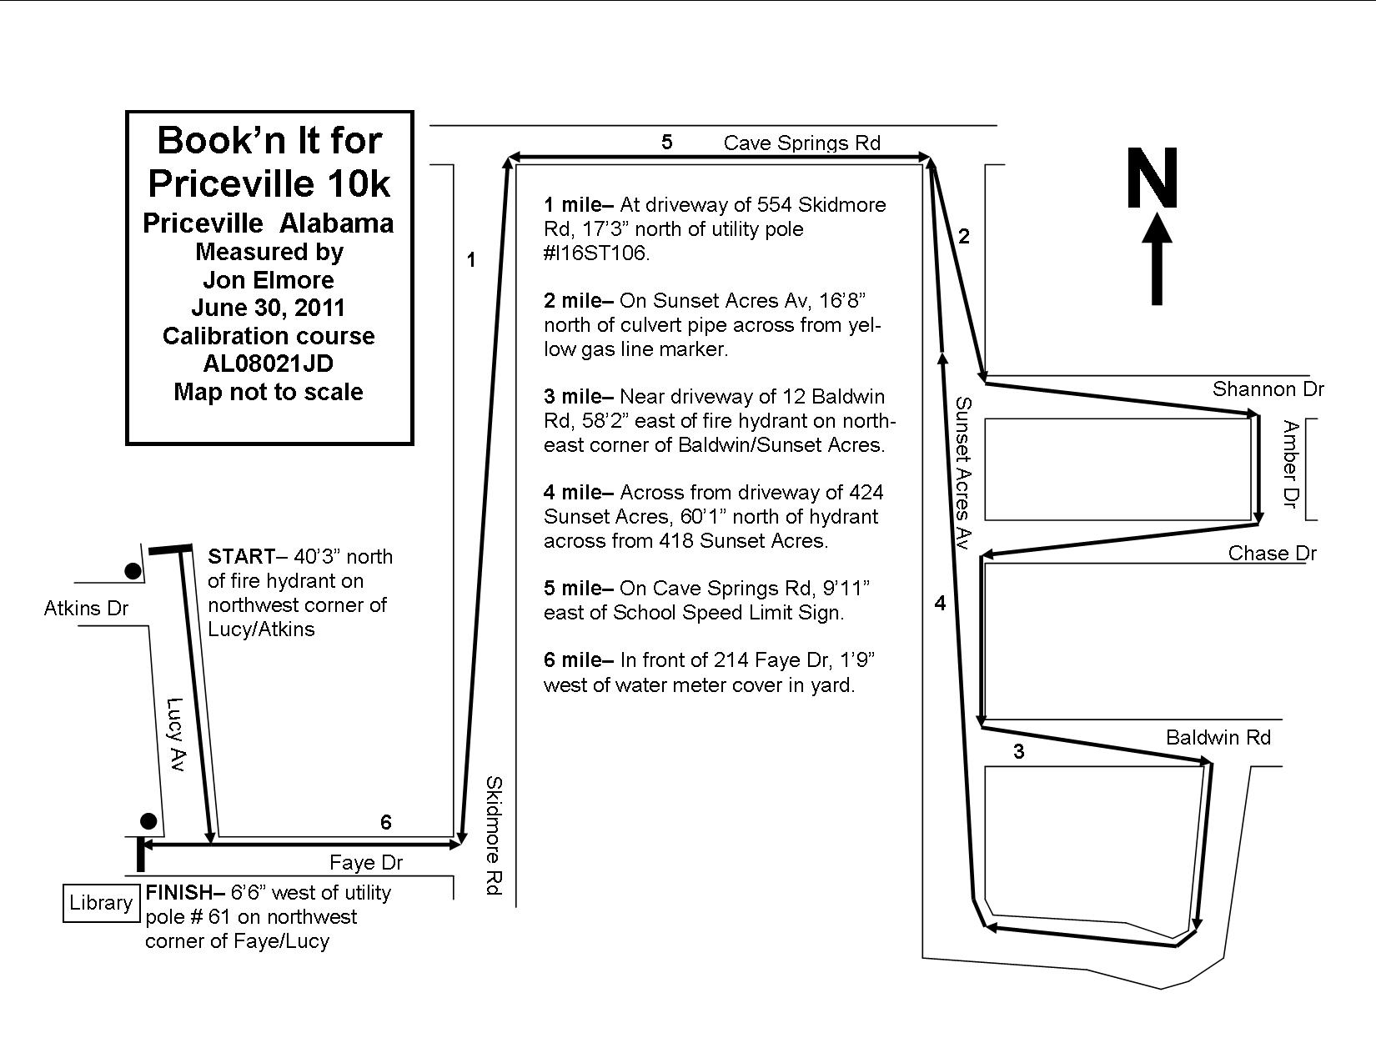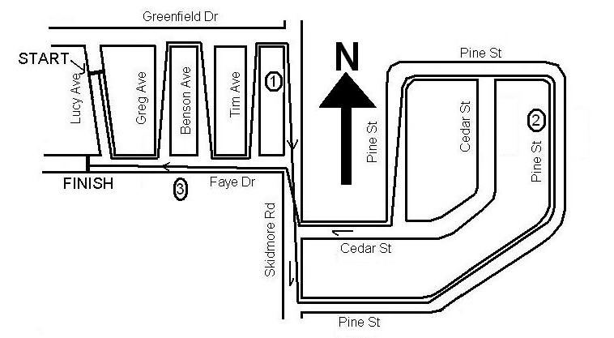
event, do hereby release, remise, waive, and forever discharge the
Road Runners Club of America, River City Runners Club, Town of
Priceville, the Linda Duran Public Library and any supporting groups
of this said event, together with all their officers, agents, officials and
employees, from any liability, claims, demands, actions, or causes of
actions whatsoever arising out of, or relating to any injury, illness, loss,
or damage, including death, relating to participation in above event.
I further state I am in proper physical condition to participate in this event.
In addition, I agree that my participation in this event requires that I
will not participate with roller skates/blades, baby joggers, skateboards,
animals, headphones, or anything which the race director deems
dangerous to me or other participants and that race director may remove
me from this event for a violation of said policy I further grant permission
to this race and the organization conducting the race and/or agents
authorized by them to use any photographs, videotapes, digital media
recordings and any other record of this event for any purpose. I also
agree that if the event is cancelled for any reason that all entry fees
Book’n It 5K
Priceville AL Measured by Jon Elmore
AL08021
are non-refundable.

X______________________________________________
Signature (Parent/Guardian if under 18) Date

Make checks payable to: Linda Duran Public Library
Mail to: Linda Duran Public Library
1612 S BETHEL RD, Priceville AL 35603

